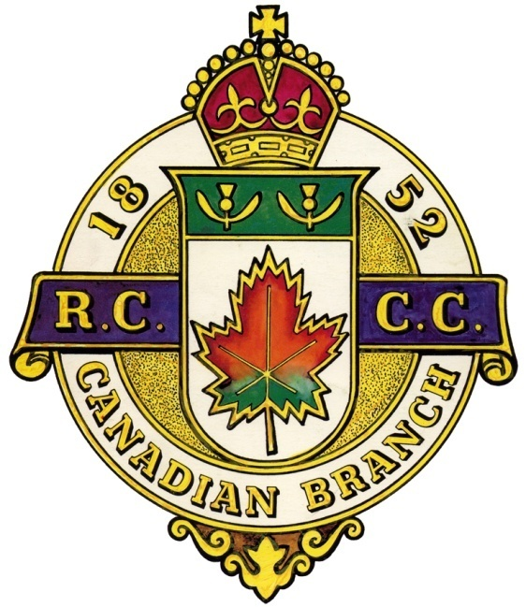
The CANADIAN BRANCH La FILIALE CANADIENNE

of the du

ROYAL CALEDONIAN CURLING CLUB
GENERAL MEETING
RÉUNION GÉNÉRALE

Friday, September 18, 2020 7:00 pm Vendredi le 18Septembre 2020 1900h

AGENDA / ORDRE DU JOUR

- Call to Order / Ouverture de l’assemblée
- Opening Remarks / Bienvenue
- Invocation / Invocation
- Moment of Silence / Un moment de recueillement
- Notice of Meeting / Avis du convocation
- Special Guests / Invités spéciaux
- Roll Call / Presences
- Agenda / L’ordre du jour
  - Motion to accept / Adoption de l’ordre du jour
- Acceptance of minutes of the last meeting (May 28 2020)
Adoption procès-verbal de la dernière assemblée (le 28 Mai 2020)
- Business arising from the minutes
Retour sur le procès-verbal
  - New events and schedule
  - Affiliation with Royal Caledonia Curling Club
  - RCCC ties for Branch executives
- Correspondance / Correspondence
- Regional Reports / Rapports régionaux
  - Montreal (District 1)
  - Outaouais & Ontario (District 2)
  - South West (District 3)
  - Mauricie (District 4)
  - L’Estrie (District 5)
  - Other
- Standing Committee Reports / Rapports des comités permanent
  - Finance – Robert Dods
  - Scheduling – Brock MacDonald
  - Competitions – Brock MacDonald
  - Juniors – Kelso Mallette
  - Gordon International – Don Robinson
  - Quebec Challenge Cup – Jim Mastine
  - Other
- Other Committees / Autres comités
  - Honorary Life Members – Bill Stevenson
  - Historian – Bill Woods
  - Past Presidents – Bill Stevenson
  - Other
- New Business / Affaires nouvelles
  - Payment of scammed funds
- President’s Closing Remarks / Allocution du Président
- Date of next meeting
- Adjournment / Fin de l’assemblée

